**PRE-REQUISITE:-**

1. python
2. tableau

**FOR INTEGRATING WE NEED:-**

tabpy server

**TABPY SERVER:-**

link for downloading tabpy server:- https://github.com/tableau/TabPy - Download zip

OR

pip install tabpy-server

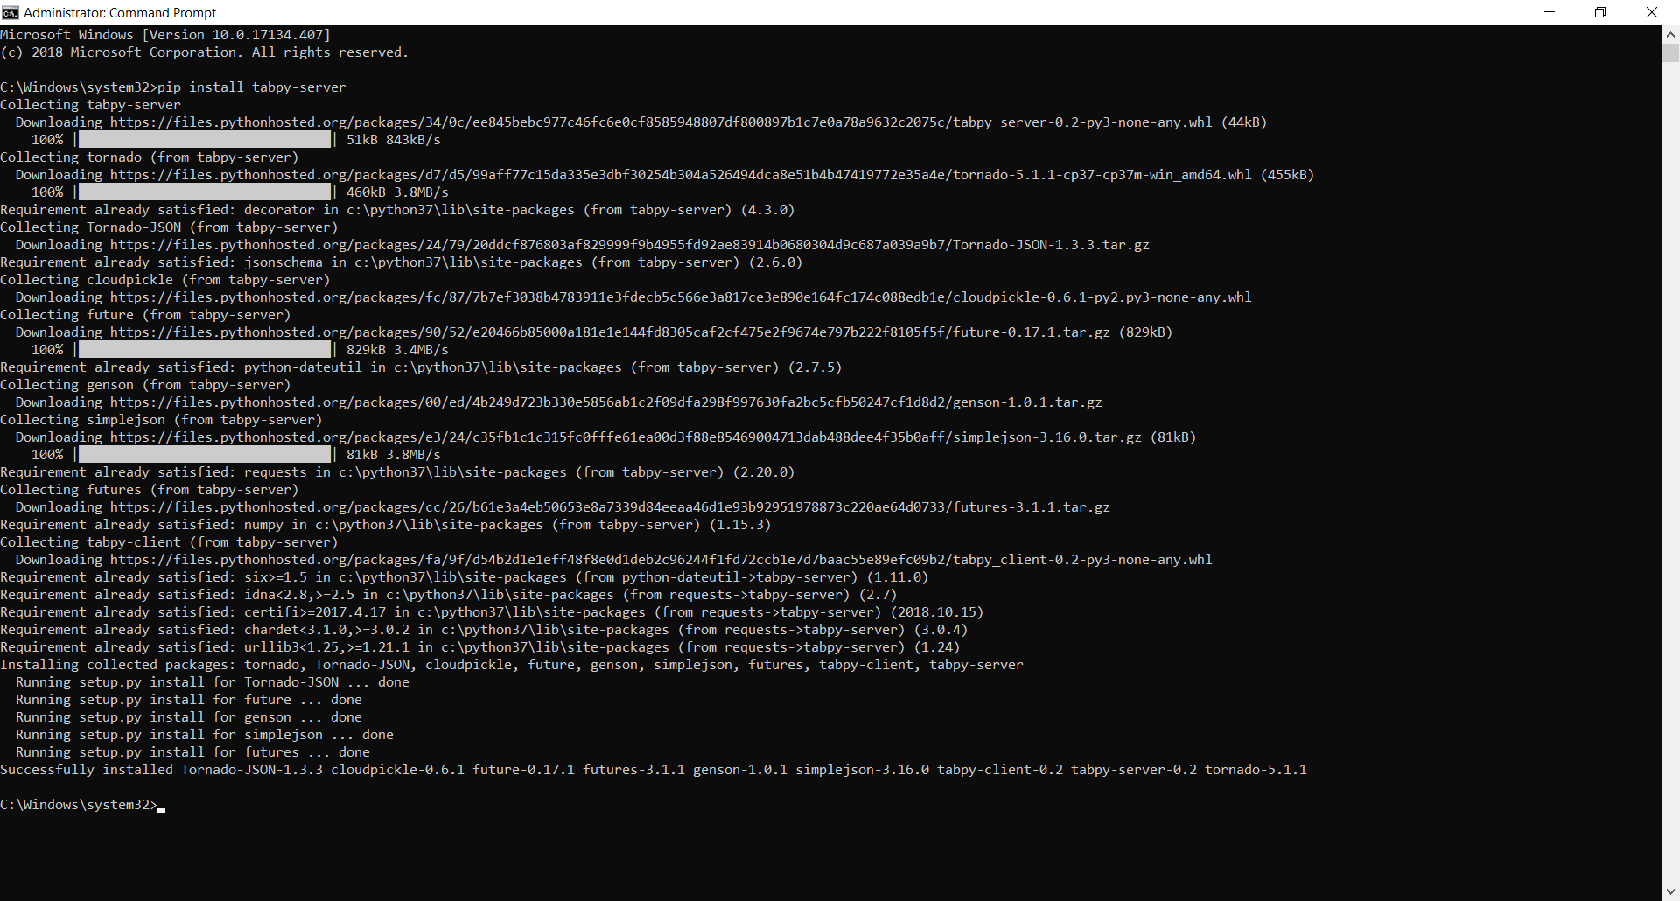

Check the folder where its installed.

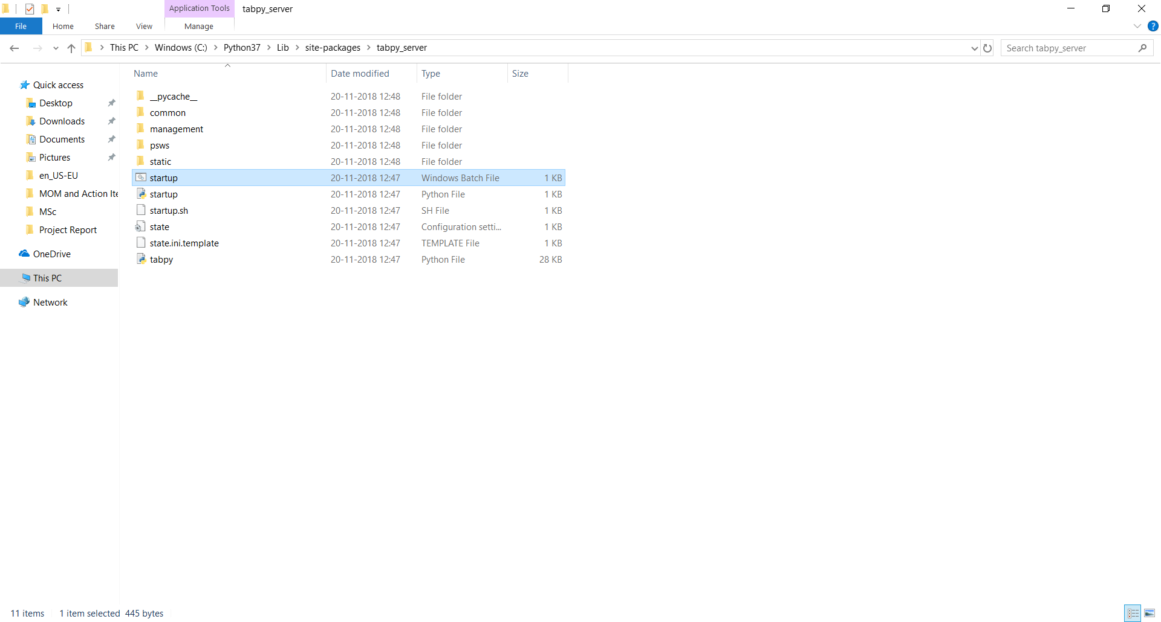

Double click on "startup" Windows batch file to start the tabpy server.

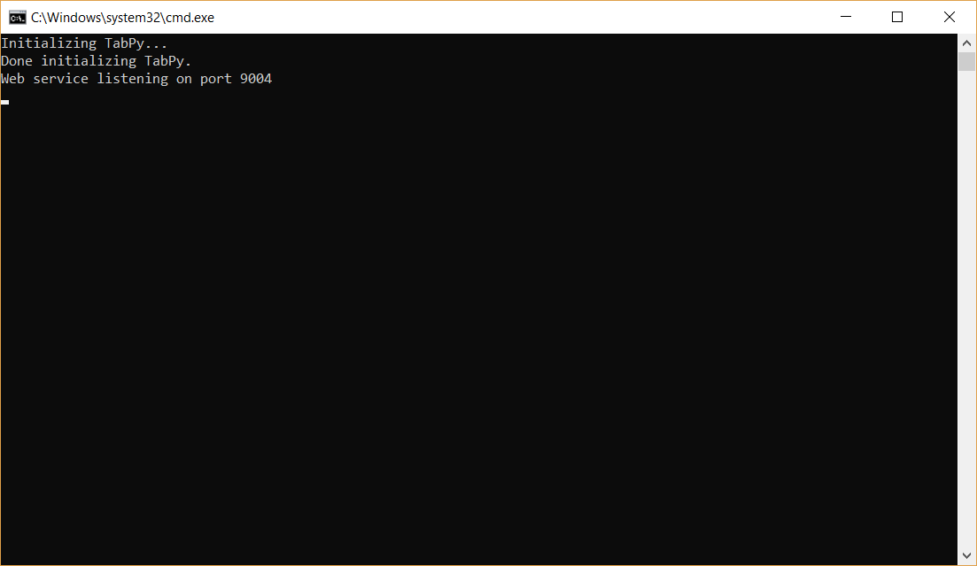

**INTEGRATE TABLEAU WITH PYTHON ON PORT 9004 (DEFAULT PORT):-**

Open Tableau

Connect - Microsoft Excel - Select dataset - Orders sheet

Help - Settings and Performance - Manage External Service Connections

Server : localhost

Port : 9004

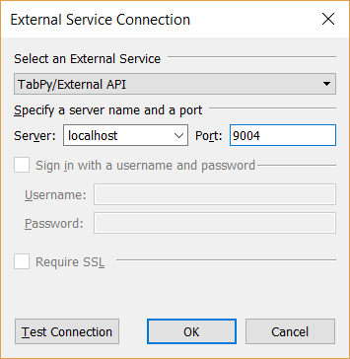

Click "Test Connection"

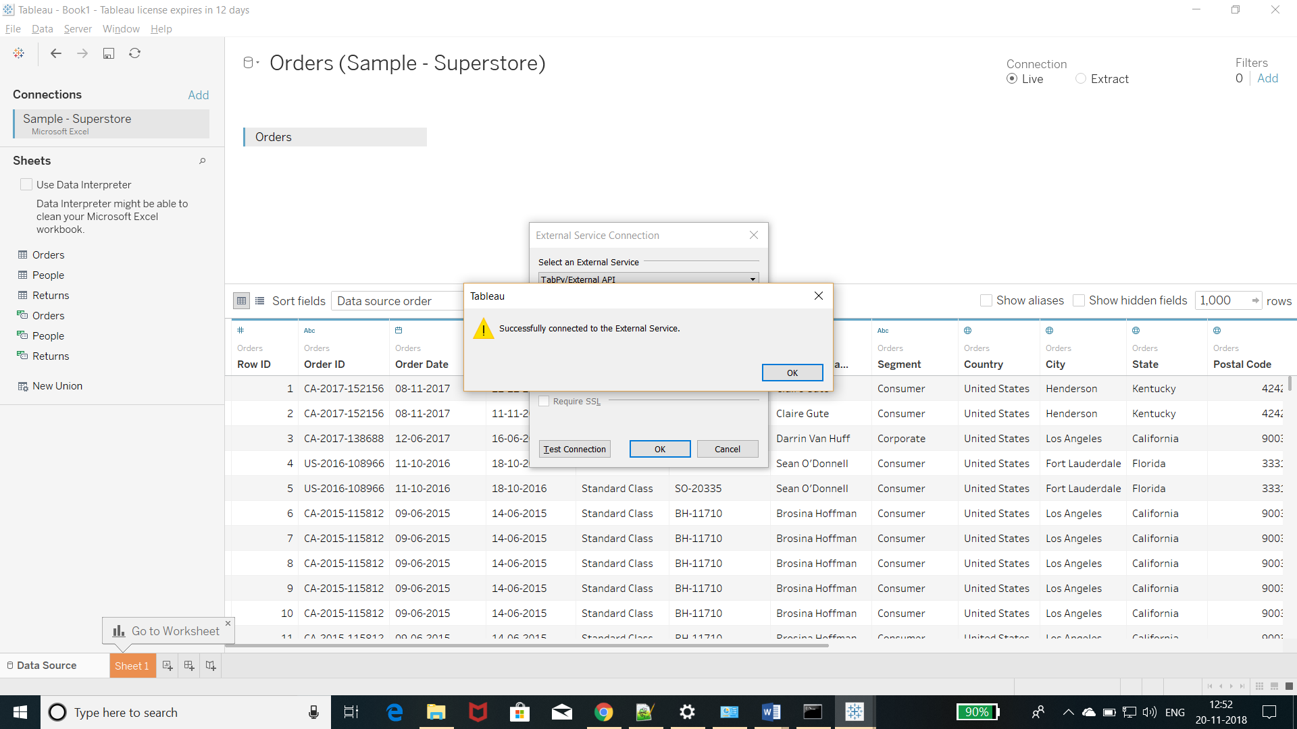

**USING TABPY SERVER:-**

Aim:- Create python calculated field in tableau to calculate where profit is greater than 4000.

1. Put "Region" in Rows.

2. Put "Profit" in "Text".

3. Now create a calculated field to store all those records and add those records into a list where profit is greater than 3000.

So, click on arrow besides Dimensions - Create Calculated Field -

Name - ProfitCalculatedField

SCRIPT_BOOL("

lst=[]

for i in _arg1:

lst.append(i>4000)

return lst",SUM([Profit]))

Click OK

4. Put "ProfitCalculatedField" in "Color".

We can edit colors too.